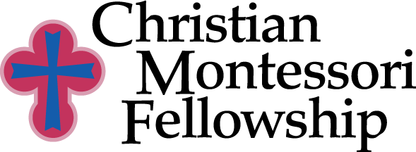

Agreement for Christian Montessori Fellowship training program
Pre-School Training

- Attendance at all scheduled classes.
- Viewing of all philosophy lectures
- Viewing of all didactic videos.
- Completion of the reading list.
- Completion of all philosophy essays.
- Successful completion of the final written and oral exams.
- Demonstration of mastery of Montessori materials
- Evidence of competency in understanding / handling of Christian Montessori pedagogy.
- Compilation of Montessori albums and teaching materials.
- Access to all on line materials/videos, written materials etc. is for your own personal use and not to be shared.
- Payment in full or monthly arrangements for payment in full are needed before the start of the course.
- It is expected that the course work should be finished within 12 months. Extensions of the time may be granted.
- An approved internship is required.
- Upon satisfactory completion of all course work, papers, exams and internship the student will be awarded CMF certification.
- MACTE certification will be awarded on completion of all requirements and payment of the MACTE fee.

It is our desire to maintain the highest integrity of training to help you to become the very best Christian Montessori teacher because the integrity and excellence of the training is a reflection of our service to God. The awarding of CMF certification is contingent on your having achieved the highest level of preparation possible. Certification is just the beginning of your real training to use this wonderful method for “the advancement of the kingdom of God.”

Name

Address

Phone

Email

Signature

